TROPICAL FOREST BIOME

Class: MS -Environmental Sciences
Session: 2019-2021
Program: Morning
Semester: 2nd
Subject: Wildlife and Forest Conservation
Submitted to: Dr. Nadia Ghani
Submitted By:
Roll numbers | Members Names
1925217002 | Aishah Mushtaq
1925217007 | Fatima Shaukat
1925217008 | Hira Ali
19252170011 | Iqra Maryam
19252170022 | Shaharbano

______________________________________________
LAHORE COLLEGE FOR WOMEN UNIVERSITY, LAHORE
ENVIRONMENTAL SCIENCE DEPARTMENT

TROPICAL FORESTS BIOME

GENERAL DESCRIPTION:
Tropical rainforests are found closer to the equator where it is warm. The tropical rainforest is a hot, moist biome where it rains all year long. It is known for its dense canopies of vegetation that form three different layers.

GEOGRAPHICAL LOCATION:
Tropical rainforests are located between the Tropic of Cancer and the Tropic of Capricorn.
The world’s largest tropical rainforests are in Amazon basin in South America, lowland regions in Africa, and the islands off of Southeast Asia.
They are found in abundant in Sumatra and New Guinea, small areas are also found in Central America and parts of Australia.

LIMITING FACTORS:
''Common limiting factor resources are environmental conditions that limit the growth, abundance, or distribution of an organism or a population of organisms in an ecosystem and also causes competition between individuals of a species population."

Some of the limiting factors includes;
- Sunlight is one of the main limiting factor.
- Water.
- Food availability.
- Amount of nutrients in the soil.
- Habitat loss or deforestation.
- Diseases in plants and animals.

TEMPERATURE- 20°C to 25°C, must remain warm and frost-free. Temperatures don't even change much between night and day.
- Summer Temperature Range- 21 to 30°C
- Winter Temperature Range- above 20°C.

PRECIPITATION- 2,000 to 10,000 millimeters of rain per year. Tropical rainforests receive annual precipitation amounts of 60 to 160 inches. Some rainforests in the world experience annual rainfall amounts of almost 400 inches. It can downpour as much as 2 inches in an hour.

HUMIDITY- The environment is pretty wet in tropical rainforests, maintaining a high humidity of 77% to 88% year-round.

RAINFALL PATTERN- Rainfall in the tropical forests is year round, annual precipitation amounts of 60 to 160 inches. Some forests in the world experience annual rain fall amounts of almost 400 inches

SOIL- Soil of tropical forest does not contain much nutrients. Soil is highly acidic. The type of clay particles in soil ha poor ability to hold nutrients. Due to high precipitation some of the nutrients washes off with the water.

SUNLIGHT- Tropical forests receive 12 hours of sunlight daily, less than 2% of that sunlight ever reaches the ground. The dense forest, canopy blocks 95% of sunlight.

FLORA:
1 | Pitcher Plants
2 | Amazon Water Lilly
3 | Epiphytes
4 | Vines
5 | Silky Oak
6 | Palm Trees- Rattan Palm, Walking Palm, Carnuba Palm, Acai Palm.
7 | Rubber Tree
8 | Corpse Flower
9 | Indian Timber Bamboo
10 | Orchids- Bucket Orchid, Vanilla Orchid

FAUNA:
Mammals | Monkeys, Bats, Possums, Kangaroos, Tigers, Foxes
Birds | African Gray Parrot, Australian King Parrot, Eagles, Hummingbirds
Insects | Beetles, Ants, Spiders, Butterflies, Grasshoppers, Caterpillars.
Reptiles and Amphibians | Snakes, Frogs, Geckos, Komodo Dragons, Chameleon
Aquatics | Eels, Piranhas, Various Fish.

HUMAN IMPACTS:
Most of this deforestation is driven by national and international economic forces.
The human impact on the Amazon rainforest has been grossly underestimated according to an international team of researchers from Brazil and the UK, led by Lancaster University.
Selective logging and surface wildfires can result in an annual loss of 54 billion tonnes of carbon from the Brazilian Amazon, increasing greenhouse gas emissions. This is equivalent to 40% of the yearly carbon loss from deforestation -- when entire forests are chopped down.
The forest degradation often starts with logging of prized trees such as mahogany and ipe. The felling and removal of these large trees often damages dozens of neighboring trees.
Once the forest has been logged, the many gaps in the canopy means it becomes much drier due to exposure to the wind and sun, increasing the risk of wildfires spreading inside the forest.
The combination of selective logging and wildfires damages turns primary forests into a thick scrub full of smaller trees and vines, which stores 40% less carbon than undisturbed forests.
So far, climate change policies on the tropics have effectively been focusing on reducing carbon emissions from deforestation only, not accounting for emissions coming from forest degradation.
Tropical Rainforests harbor 50% of world’s biodiversity, the massive deforestation of the forest has caused the total land mass to go 15 million km squared to about 8 million km squared, this is nearly half; it is estimated that nearly 2% of the rainforest is lost annually.
Furthermore, approximately 137 species are lost in this biome per day, including both species of plants and animals and insects.
The role of humans in the deforestation of the world's forests is considerable and extensive. Many activities contribute to this loss including subsistence activities, oil extraction, logging, mining, fires, war, commercial agriculture, cattle ranching, hydroelectric projects, pollution, hunting and poaching, the collection of fuel wood and building material, and road construction.
Under current practices, extractive industries (timber, oil, and mineral) promote the development of short term booms that encourage settlement. These booms and resulting settlements can attract large numbers of poor seeking a better life.
They clear the surrounding land for agriculture and livestock. Meanwhile, the forest resource, whether it be oil, timber, or minerals, is rapidly depleted with little consideration for the long-term consequences.
Once the resource is exhausted, developers move on to new areas, leaving behind a degraded environment and settlers with few livelihood options.
Where forest remains, it may be cleared for subsistence agriculture. Most extractive processes in the rainforest are not sustainable as currently practiced.

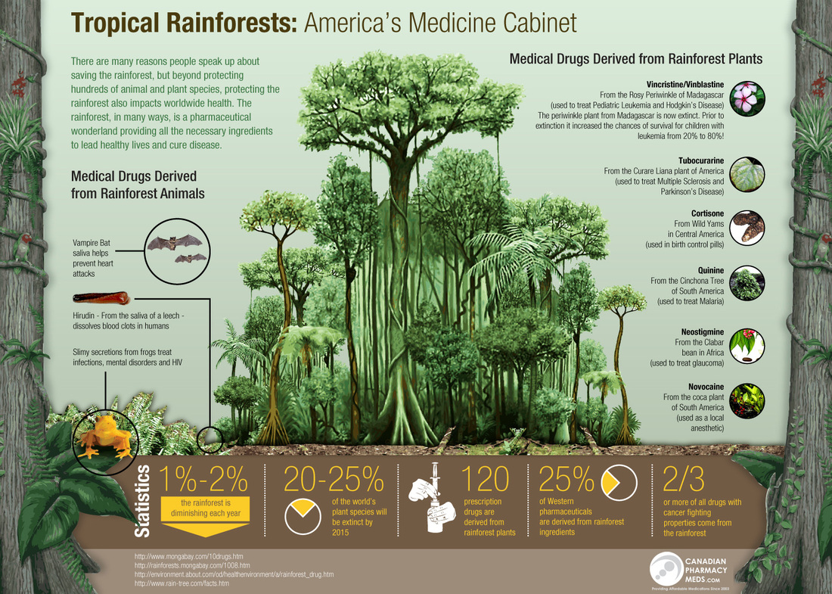
REFERENCES:
- https://earthobservatory.nasa.gov/experiments/biome/biorainforest.php
- https://www.conserve-energy-future.com/tropical-rainforest-biome.php
- https://prezi.com/p/xtu0ayga8oi4/tropical-rainforest-limiting-factors/
- https://wtamu.edu/cbird/sq/mobile/2013/07/12/-the-soil -in tropicalforests
- www.cotf.edu>earthsysflr>forestP
- https://www.blueplanetbiomes.organisms
- https://www.conserve-energy-future.com
- Berenguer, R., Ferreira, J., Gardner, A.T., Aragão, C.O.E.L., de Camargo, B.P., Cerri, E.C., Durigan, M., Junior, O.C.R., Vieira and G. C.I., Barlow. J., 2014.A Large-Scale Field Assessment of Carbon Stocks in Human-Modified Tropical Forests. Global Change Biology
- https://rainforests.mongabay.com/0803.htm

